**WEEK-5**

**MICROSERVICES WITH API GATEWAY**

**MICROSERVICES WITH SPRING BOOT 3 AND SPRING CLOUD**

**Creating Microservices for account and loan**

**CODE:**

**Step 1: Create folder, inside that, create a folder called microservices**

**Step 2: Generate Account Microservice, Use Spring Initializr and download the ZIP file.**

**Step 3: Extract the ZIP file and import it to Eclipse IDE**

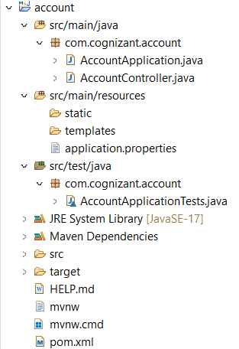

**Step 4: Create AccountController.java in com.cognizant.account.controller**

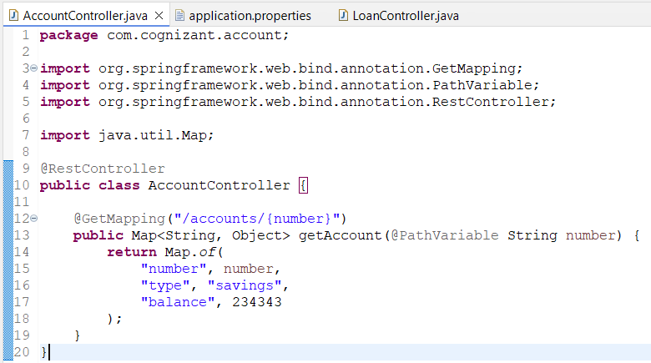

**Step 5: Run & Test Account Service and in browser go to url http://localhost:8080/accounts/00987987973432**

**OUTPUT:**

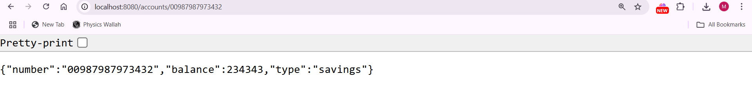

**Console Output:**

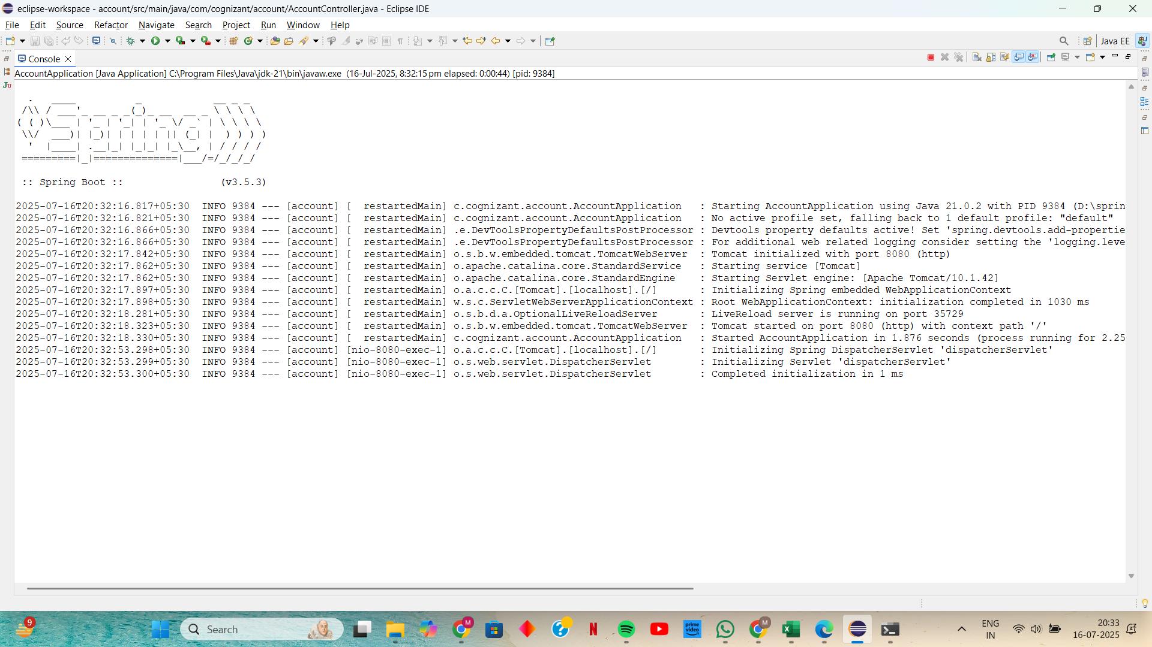

**Step 6: Similarly Generate Loan Microservice and Import it to eclipse**

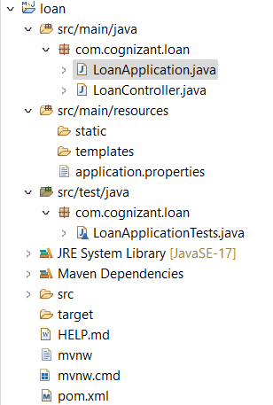

**Step 7: Create LoanController.java in com.cognizant.loan.controller**

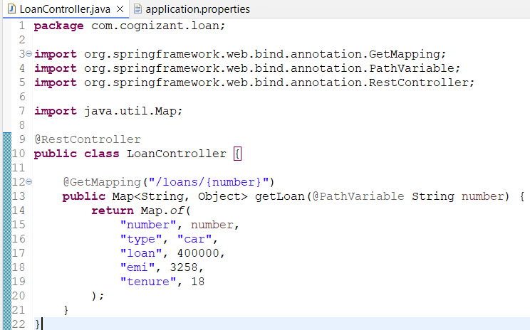

**Step 8: Change Port for Loan Service by Editing src/main/resources/application.properties of the loan project**

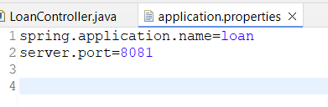

**Step 9: Run & Test Loan Service and go to** [**http://localhost:8081/loans/H00987987972342**](http://localhost:8081/loans/H00987987972342)

**OUTPUT:**

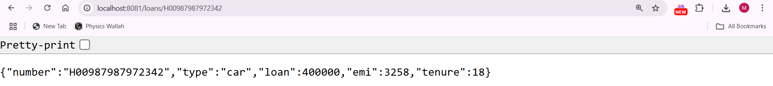

**Console Output:**

